Assignment 1 Report

I learnt about different types of Digital Images like gray scale images,color images like RGB,CMY.
I learnt conversion between RGB to gray scale format .

Reasons for applying image processing techniques to images:
To reduce system and sensor noises,motion errors,Atmosphere interferences etc...

So errors arise internally or externally.Internal errors arise due to caliberation measurements.
External erros are difficult to characterise and are random in nature.They arise due to platform perturbations and modulation of scene characterstics.

Preprocessing includes radiometric and geometric corrections.So we assume our images are free from such radiometric and geometric erros.

In this assignment mostly noise filters were used for image enhancement.
Filtering is performed by using convolution windows.The kernel windows may be of size 3*3,5*5 etc.....

Gaussian Blur:
This blurs the given image.This reduces the image noise and also details of the image.
The kernel parameters like variance in x and y directions.

Original Image Kernel of size 13*13 kernel of size 29*29


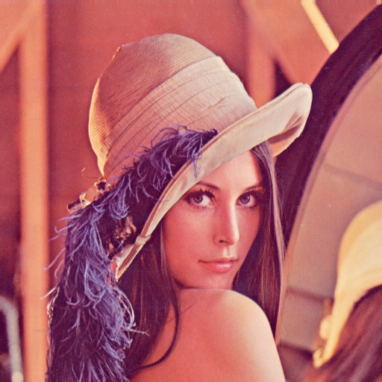

Gaussian blur is a low pass filter.

Gaussian blurs have nice properties, such as having no sharp edges, and thus do not introduce ringing into the filtered image.

We cam program our own Gaussian blur without using built in libraries by providing appropriate variance values and calculating the Gaussian matrix.

For this we should calculate gaussian probability at each pixel and normalise them to 1.
Now multiply these values with gray scale pixel values accordingly and hence our matrix.

Bilateral Filter:
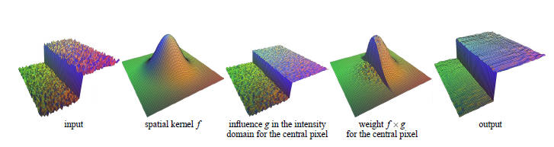
Original Image Bilateral 27*27
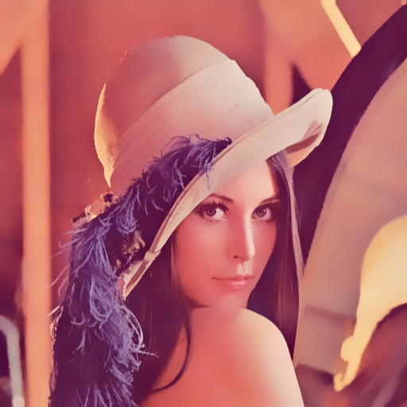

Bilateral filter is edge preserving and noise reducing smoothing filter.
In smooth regions Bilateral filter acts like any other standard filter.
Two close pixels may be close becoz of their spatial location or similar pixel values.
Bilateral filter buils matrix taking into account photometric similarity between pixels and hence edges are preserved.

Canny Edge Detector:
It detects only existing edges and only one detector response per edge.
It gives user choice to select lowe rthreshold and upper threshold.A pixel higher than upper threshold is considered as edge.A pixel in between these values is considered if it is connected a edge.Upper/lower ratio can vary between 2:1 to 3:1.

